Молдавский Государственный Университет

Факультет Математики и Информатики

Специальность: Прикладная Информатика

ДЗ 4

Преподаватель: Бодруг С  
Студент: Кадомцев А  
группа IA1902

Кишинёв 2021

**Задание №1:**

**Запустить локально.**

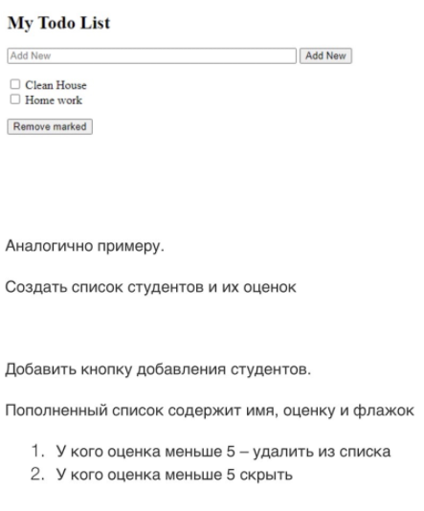

**Выполнение:**

<!DOCTYPE html>

<html>

<head>

<title>Cadomtev Alex Homework</title>

<script src = "https://ajax.googleapis.com/ajax/libs/angularjs/1.3.14/angular.min.js">

</script>

</head>

<body ng-app="myApp" ng-controller="todoCtrl">

<h2>Students</h2>

<form ng-submit="todoAdd()">

<input type="text" ng-model="Name" size="30" placeholder="Name">

<input type="number" min="1" max="10" ng-model="Mark" size="10" placeholder="Mark">

<input type="submit" value="Add New Student">

</form>

<div ng-repeat="x in todoList">

<input type="checkbox" ng-model="x.done"> <span ng-bind="x.Name"></span>, mark:<span ng-bind="x.Mark"></span>

</div>

<p><button ng-click="remove()">Remove marked</button></p>

<p><button ng-click="remove_neg()">Remove students with negative mark</button></p>

<script>

var app = angular.module('myApp', []);

app.controller('todoCtrl', function($scope) {

$scope.todoList = [{Name:'John', Mark: '8', done:false}];

$scope.todoAdd = function() {

$scope.todoList.push({Name:$scope.Name, Mark:$scope.Mark, done:false});

$scope.Name = "";

$scope.Mark = "";

};

$scope.remove = function() {

var oldList = $scope.todoList;

$scope.todoList = [];

angular.forEach(oldList, function(x) {

if (!x.done) $scope.todoList.push(x);

});

};

$scope.remove_neg = function() {

var oldList = $scope.todoList;

$scope.todoList = [];

angular.forEach(oldList, function(x) {

if (x.Mark >= 5) $scope.todoList.push(x);

});

};

});

</script>

</body>

</html>

**Результат:**

